Chapter 16, Problem 65.

For the RLC circuit shown in Fig. 16.88, find the complete response if v(0) = 2 V when the switch is closed.

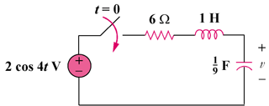

Figure 16.88
For Prob. 16.65.

